Video on the web using Adobe/MacromediaFlash
V2 - 14/05/09
Objective:-

To place a video onto the web on a webpage so that it is of a reasonable size, good sound quality, preserves either the 4:3 (720 x 540) or 16:9 (720 x 405) format, and of as small a file size as possible using Adobe/Macromedia Flash and Adobe/Macromedia Dreamweaver.

Note: The best results are produced by configuring and preparing your Flash video ready for a Streaming Service provided by an ISP but this is probably too expensive unless you are a big company.

The alternative is to use the Progressive Download option in Flash which will take the completed video a little while to down load where a slow internet connection exists on the PC viewing the video. Most times with broadband connections the video start is instant with this method.

Part 1 – Producing a source file of your video

- Using Pinnacle, click the Make a Movie tab
- Select the File option
- Choose the file type by click the wmv (Windows MoVie – look for the Windows icon/logo on the page) option as this preserves a 16:9 format and produces a smaller file size.
- Then select preset = High Quality PAL for a decent web-size file which is not too large.
- Click Create file, choose a destination folder for your .wmv file then click OK
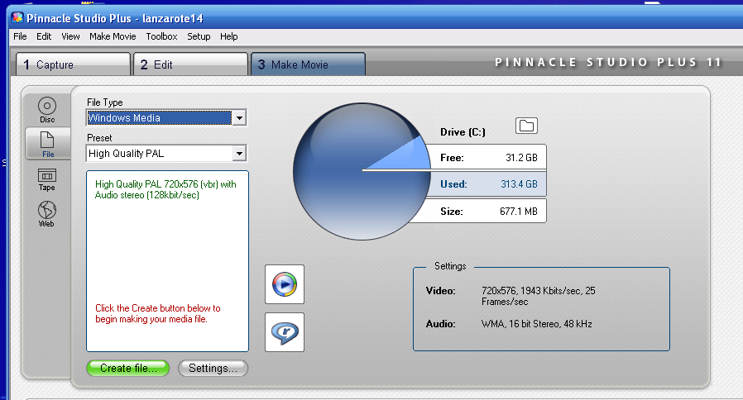

Note: It is important to keep EVERY file associated with this complete web video operation in the SAME folder. Believe me it makes it much easier!

Note: If your movie is on a DVD then Pinnacle will allow you to import the footage using the
File > Import DVD Titles option, then drag the footage into the timeline then produce your wmv file.

Note: If you need to produce a .avi file type, then DirectX 9 (minimum version) and Apple Quicktime 6.5 (minimum version) for Windows must be previously installed to allow the import to progress.

- Your file will render and produce the .wmv file – this will obviously take quite a while – 20 min film took 90 minutes-plus
- .Now proceed to the next stage.

Part 2 – Importing the video into Flash for conversion

- Open Flash (Flash Professional 8 was used when writing these instructions)
- Set the stage size and background colour of your movie by clicking on the size button. The stage should be bigger than the movie of course and black is a good colour to use. Set your Frame rate to 25fps for smooth video
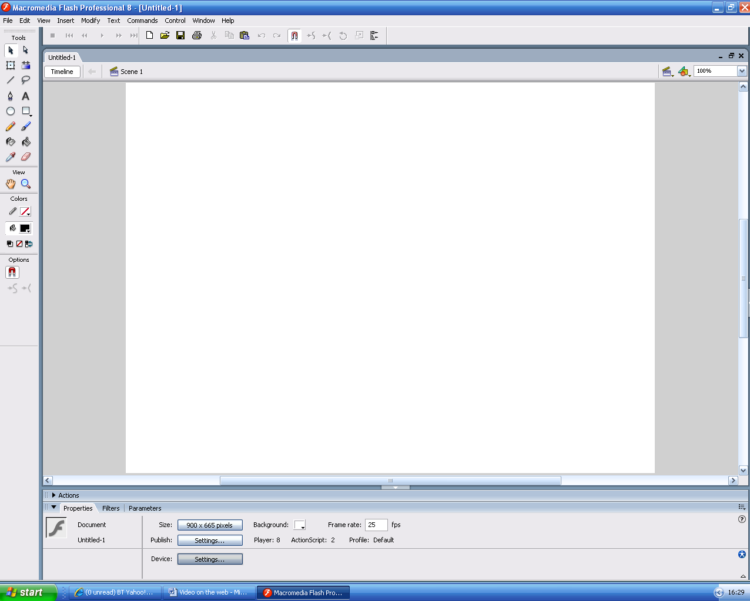

- File > Import > Import Video
- Select the File Path type ‘on your computer’.
- On the first page, browse to find the .wmv file to be added
- Click Next
- Deploy video by ‘Progressive Download’ option if no Streaming Service has been arranged with ISP
- Click Next
- Select Playback quality (Medium 400 kbps? Remember to keep your file sizes as small as possible)
- Click Next
- Choose playback skin. This dictates the type and style of transport controls to be seen on the webpage

Note: A skin with ‘Over-All’ in the title will hide the bottom of the film whereas a skin with
‘External’ in the title places the controls after the bottom of the film so that the complete height of the film may be seen. Also if you select a skin with All in the title you will get a full set of transport controls

- Click Next
- For 16:9 format click on the Resize and Crop tab and for a 720pixel wide 16:9 format, reduce size to 405pixel otherwise film will be squeezed into 4:3 format.
Doh! on’t forget to de-click the Maintain Proportions check box otherwise you’ll have a 4:3 size film again but only smaller!

- On Final page click Finish
- Navigate to the folder where the file will be saved (remember use just one folder to store every file!)
- Enter file name
- Click Save and the Video will be compiled into a .flv file.

Note The video will compile into Flash – this may take some time
This .flv file and the resultant .swf file generated and the skin .swf file
generated must all be uploaded to the server in a later stage. Note that
all these 3 files will appear in the folder defined in 14 above when
complete. This process takes roughly the same amount of time as the
actual film is in playback length

- Once the video has compiled it will be added to the Flash stage and you will see it as an object – a box with a Flash icon in the middle
- Now check the Flash timeline. If the movie has been added to Flash over a number of frames, click the penultimate frame (keyframe) and hold down shift and click the first frame to select all the frames bar the last one. When selected, right click the movie’s layer and click Remove Frames. This will remove all the excess frames and leave the movie as a layer containing a single keyframe.
Note: It is a good idea to set an ActionScript ‘stop’ command for the end of the video on the timeline but not essential. This just makes sure that the video stops at the end of the film.
- Next click File > Publish Settings
- Click on the Format tab
- Enter the name of the finished .swf file and the folder where it is to be saved by clicking the folder icon to the right and navigating to that folder
- Enter the name of the html file (webpage) and the folder where it is to be saved by clicking the folder icon to the right and navigating to that folder
- Click on the Flash tab
- Set the options… Protect from Import, Compress Movie, JPG Quality and if you want CD quality sound (bigger file of course!) then set Audio Stream and Audio event to 128kbps
- Click on the HTML tab
- Set HTML options which can mostly be set to default but if you want playback to be paused at start, looped then these can be set as options too. Note that the alignment of the flash player on the page may also be set
- Click Publish
- Click OK
- At this point a .swf (compiled flash object file is produced along with a basic webpage. You can use this simple webpage if you but you can design your own if a more integrated look is required.

Part 3 – Adding the movie to a custom designed webpage

- Open Dreamweaver
- Click on a place where you want the movie to be seen (you can insert a table to be really accurate) and click Insert > Media > Flash
- Navigate to the .swf file of your movie and click OK
- The movie will be added to the webpage.
- Do any further layout customisiation to the page but remember to save the page in the same folder as all of the other files

Part 4 Uploading the files to the server

- Now upload the following files using what ever FTP programme you use in the usual way – this can take quite a while too depending on your film
- the HTML page (either your designed one or the automatically generated one)
- the Flash .flv file
- the Flash .swf file
- the .swf skin file to your server
- javascript runactivecontent file
Typically upload ALL the files in your folder to your server except the wmv file which
is substituted for the .flv file

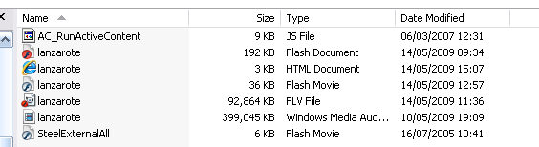
- Now view the page on the web and check for video and sound

